Assignment 1:Solving Big data problem & Hadoop framework

a. After successsful installation of Oracle VM and importing Acadgild_bit.ova inside it, i ran the following command:
start-all.sh followed by jps
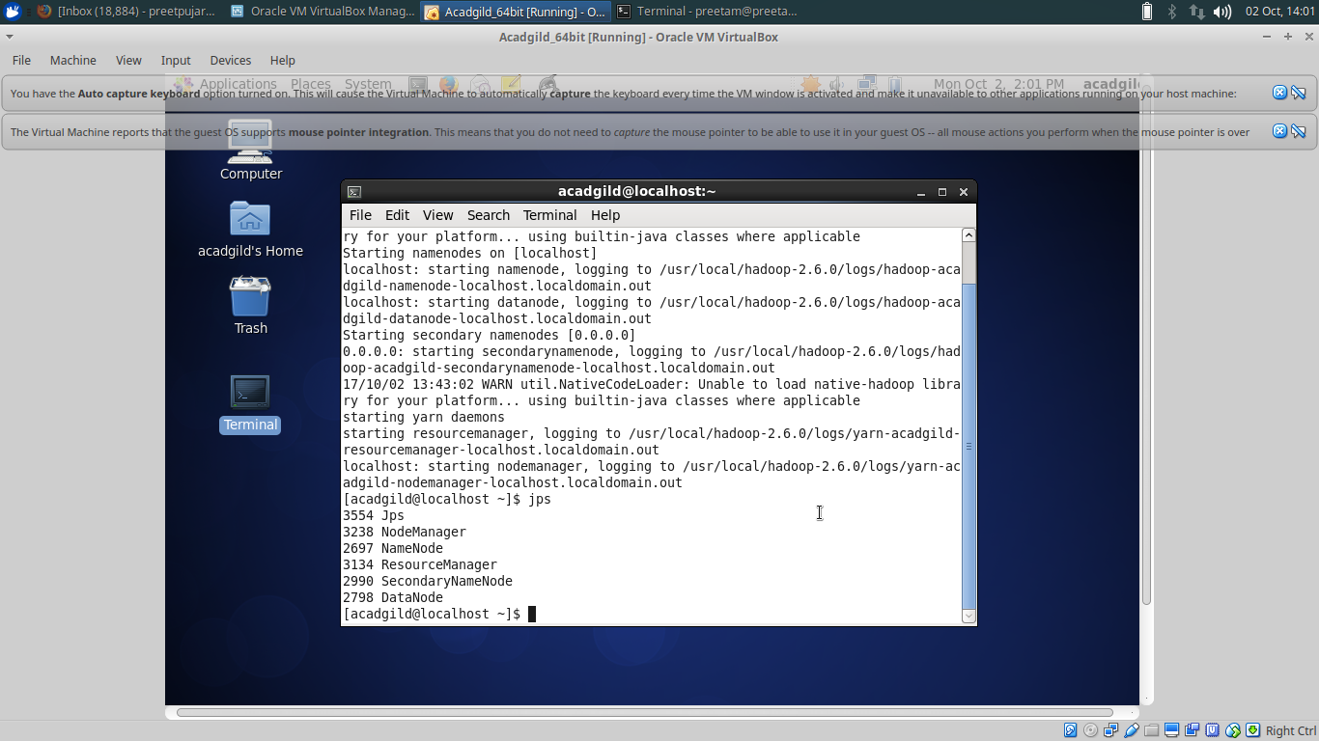
(Please refer the below screenshots)

b.History server command
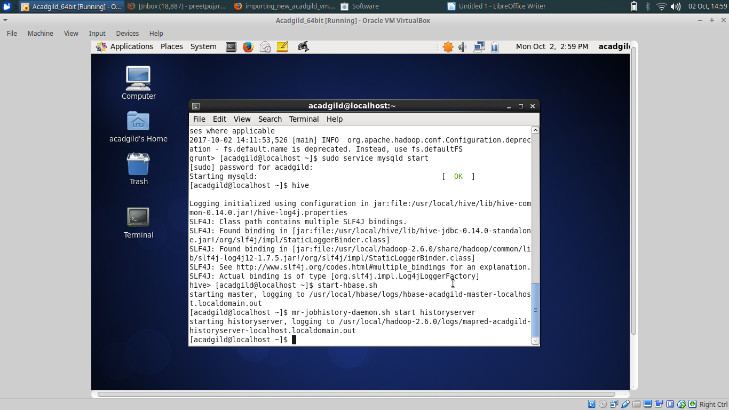

c.Pig command
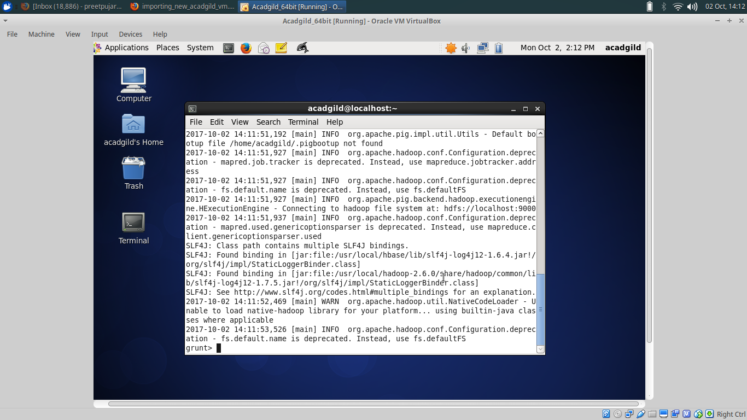
d.hive
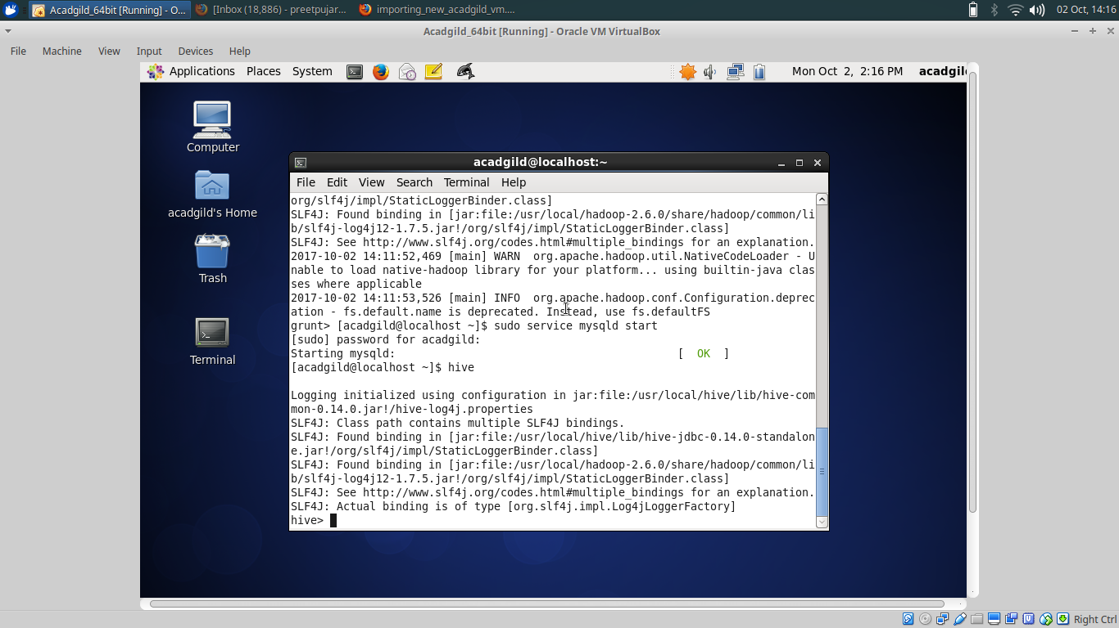

e.sudo service mysqld start
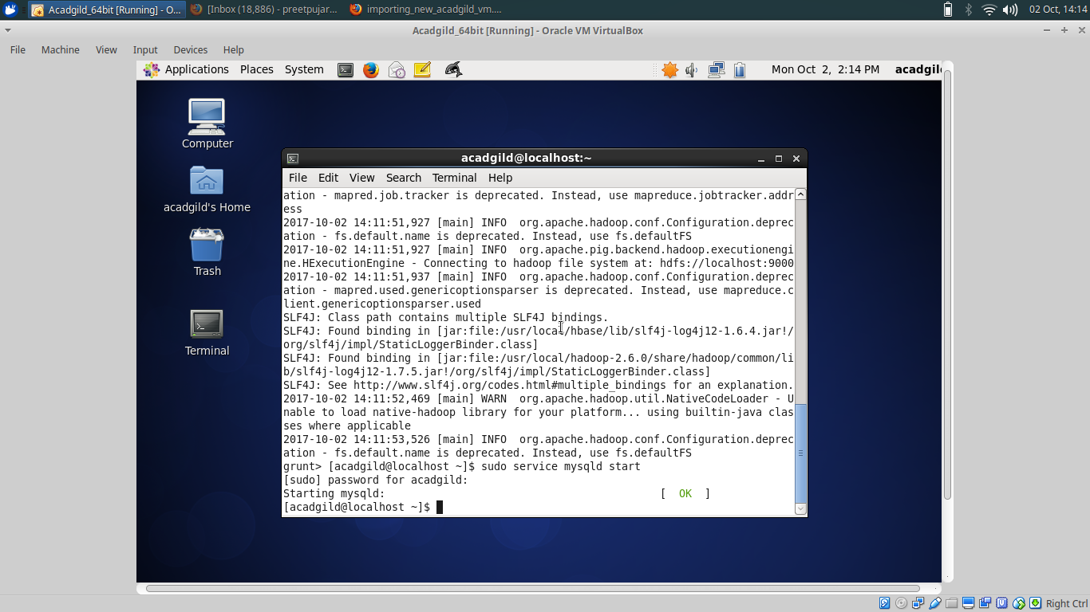
e.hbase
